

JAVA PROJECT REPORT ON

Digital student id management system

Submitted by
DHARSHINI PRIYA A
25BCS110

Under the Guidance of
Mr Aravind
Technical Trainer
Technical Department, KG College of Arts and Science

Academic Year: 2025 – 2026
APRIL 2026
Semester: II
DECLARATION
I hereby declare that the project entitled “ Digital student id management system” submitted in partial fulfillment of the requirements for the course BSC Computer science is a record of my original work carried out under the guidance of Mr Aravind, Technical Trainer, Technical Department, KG College of Arts and Science.
I further declare that this project has not been submitted previously, either in part or in full, for the award of any degree, diploma, or other similar title, at this or any other institution.
I have acknowledged all sources of information used in this project wherever applicable.

April 2026
Coimbatore

_____Dharshinipriya_

CERTIFICATE
This is to certify that the project entitled “Digital student id management system” is a bona fide work carried out by Dharshini priya A,1st year-B ,BSC Computer science, KG College of Arts & Science, in partial fulfillment of the requirements for the course Java programming.
This project has been completed under my supervision and guidance during the academic period April 2026.

Place: Coimbatore
Date: 10/04/2026

Submitted for the Viva-Voce Examination held on ___10/04/2026_______________________________

Guide Head of the Department
(Technical Trainer, KGCAS) (Technical Head, KGCAS)

___Mr Aravind___________________ ___BooplanSundaramoorthy_______

TABLE OF CONTENTS
S. No. | Topics | Page. No.
1 | Introduction | 6
1.1 | Objective | 6
1.2 | Overview | 6
1.3 | Features | 7
2 | Program Analysis | 8
2.1 | Problem Definition | 8
2.2 | Project Overview | 8
2.3 | Scopes and Limitations | 9
3 | System Design | 10
3.1 | Modules | 10
4 | Methodology | 12
4.1 | Problem Analysis | 12
4.2 | System Design | 13
4.3 | Program Development | 13
4.4 | Testing and Validation | 14
4.5 | Result and Documentation | 14
4.6 | Algorithm | 15
4.7 | Flowchart | 15
5 | Source Code | 18
6 | Input and Output Screens | 20
7 | Discussion and Conclusion | 21
7.1 | Discussion | 21
7.2 | Conclusion | 21
8 | References | 22

ABSTRACT

The Digital Student ID Management System is a Java-based application designed to efficiently manage student identity information in a digital format. In traditional systems, student records and identification cards are maintained manually, which leads to several issues such as data redundancy, time consumption, lack of security, and difficulty in accessing information. This project aims to overcome these limitations by providing a computerized solution that ensures accuracy, efficiency, and security.The system allows administrators to store, manage, and retrieve student details such as student ID, name, department, year of study, and contact information. Each student is assigned a unique identification number, which serves as their digital identity within the institution. The application also supports operations such as adding new student records, updating existing information, deleting records, and searching for specific student details.One of the key features of this system is the generation of digital ID cards. These digital IDs eliminate the need for physical cards, reducing the risk of loss or damage. The digital ID can be accessed at any time and used for various institutional purposes such as verification, attendance tracking, and administrative processes.The system is developed using Java programming language, which ensures platform independence and robustness. The frontend is designed using user-friendly interfaces, while the backend handles data storage using file handling or database systems. The use of structured programming and modular design improves maintainability and scalability.This project also focuses on improving data security by implementing login authentication mechanisms. Only authorized users can access or modify the data, ensuring confidentiality and integrity of student information. Additionally, the system reduces manual errors and speeds up the process of data handling.Overall, the Digital Student ID Management System provides a reliable and efficient solution for managing student identity data. It simplifies administrative tasks, improves record management, and enhances the overall productivity of educational institutions. The system can be further enhanced with advanced technologies such as cloud computing, QR codes, and mobile applications to make it more powerful and versatile.

- INTRODUCTION

The main objective of the Digital Student ID Management System is to develop an efficient and automated system for managing student identity information using Java technology. In traditional systems, student identification is handled manually through physical ID cards, which may be lost, damaged, or misused. To overcome these issues, this project introduces a digital platform where student information is securely stored, managed, and accessed electronically.The system aims to provide a centralized database that stores all student-related data such as name, roll number, department, year of study, contact details, and unique ID number. The objective is to reduce paperwork, improve efficiency, and enhance data security. It also helps administrators to easily manage student records and update them whenever required.Another important objective of this system is to generate a digital ID card for each student that can be accessed anytime through the system. This ensures that students do not need to carry physical ID cards all the time. The digital ID can be used for verification purposes within the institution, such as library access, attendance tracking, and exam verification.Additionally, the system is designed to minimize human errors that occur in manual data handling. It provides accurate, fast, and reliable data processing. The use of Java ensures platform independence, robustness, and scalability of the system.Overall, the objective of this project is to create a user-friendly, secure, and efficient system that simplifies student identity management in educational institutions.
1.1 Objective

The main objective of the Digital Student ID Management System is to develop a reliable, efficient, and secure software application that manages student identity information in a digital format using Java. The system aims to replace the traditional manual methods of handling student records and physical ID cards with a modern, automated solution.In many educational institutions, student identification is managed using physical ID cards and paper-based records. This approach is time-consuming, prone to errors, and difficult to maintain. The objective of this project is to overcome these limitations by introducing a computerized system that simplifies the process of storing, accessing, and managing student data.
One of the primary objectives of this system is to create a centralized database where all student information is stored in an organized manner. This includes details such as student ID, name, department, year of study, and contact information. By maintaining a centralized system, it becomes easier to retrieve and update data whenever required.Another important objective is to generate digital ID cards for students. These digital IDs serve as a unique identity for each student and eliminate the need for physical cards. This reduces the chances of loss, damage, or misuse of ID cards. The digital ID can be accessed anytime and can be used for various institutional purposes such as verification, attendance, and library usage.The system also aims to improve efficiency and save time. In a manual system, searching for student records can take a lot of time, especially when dealing with large volumes of data. The digital system allows quick retrieval of information using search functionality, thereby increasing productivity.Data accuracy and error reduction are also key objectives of this project. Manual data entry often leads to mistakes, duplication, and inconsistency. The system ensures proper validation and structured data storage, which helps in maintaining accurate and consistent records.Security is another major objective. The system includes a login authentication mechanism to ensure that only authorized users can access or modify student data. This helps in protecting sensitive information from unauthorized access and ensures data confidentiality.In addition, the system is designed to be user-friendly so that even users with basic computer knowledge can operate it easily. The interface is simple and intuitive, reducing the learning curve for administrators.Another objective is scalability and flexibility. The system is developed in such a way that it can handle a large number of student records and can be easily expanded in the future. New features such as mobile access, QR code integration, and cloud storage can be added as enhancements.Furthermore, the project aims to demonstrate the practical application of Java programming and software development concepts such as object-oriented programming, modular design, and database management1.2 OverviewThe Digital Student ID Management System is a software application developed using Java that helps institutions manage

1.2 Overview

The Digital Student ID Management System is a software application developed using Java that helps institutions manage student identity records digitally. It replaces the traditional ID card system with a modern and efficient digital solution.This system consists of different modules such as student registration, ID generation, data storage, and retrieval. The administrator has full control over the system and can add, update, delete, and view student records. Each student is assigned a unique ID, which acts as their digital identity within the institution.The system works based on a database where all the information is stored. When a new student joins, their details are entered into the system. The system then generates a digital ID card automatically. This ID can include details such as student name, photo, department, and ID number.One of the major advantages of this system is easy accessibility. Authorized users can access student information quickly without searching through physical files. It also improves data security by restricting access through login credentials.The system can be integrated with other institutional systems such as attendance management, library systems, and examination systems. This makes it a versatile tool for overall campus management.
In addition, the system supports data backup and recovery features to ensure that no information is lost. It is designed in a way that it can handle a large number of student records efficiently.
1.3 Features

The Digital Student ID Management System provides several important features that make it efficient and user-friendly.1. Student RegistrationThe system allows administrators to register new students by entering their personal and academic details. This includes name, roll number, department, contact information, and photograph.
2. Digital ID GenerationOnce the student details are entered, the system automatically generates a digital ID card. This ID card contains all necessary information and can be displayed on screen.
3. Secure Login SystemThe system includes authentication features such as username and password for administrators. This ensures that only authorized users can access or modify the data.
4. Data Storage and ManagementAll student data is stored in a database. The system allows users to add, update, delete, and retrieve student information easily.
5. Search FunctionalityThe system provides a search option to quickly find student records using ID number or name. This reduces time and effort.
6. Error ReductionBy automating the process, the system reduces human errors in data entry and management.
7. ScalabilityThe system can handle a large number of student records without affecting performance.
8. User-Friendly InterfaceThe interface is simple and easy to use, making it suitable for users with basic computer knowledge.
9. Data SecuritySensitive student information is protected using secure coding practices and access control mechanisms.
10. Report GenerationThe system can generate reports of student data, which can be used for administrative purposes.

- PROGRAM ANALYSIS

Program analysis is an important phase in software development where the problem is studied in detail and the requirements of the system are identified. This stage helps in understanding how the system should work and what features are required to solve the problem efficiently.The analysis phase focuses on identifying the current issues in the existing system and proposing a computerized solution that improves efficiency and accuracy.
2.1 Problem Definition

In many educational institutions, student identification and record management are still handled manually or with outdated systems. Physical ID cards are commonly used for identification, but they come with several limitations such as loss, damage, duplication, and difficulty in updating information. Managing large volumes of student data manually can lead to errors, inefficiency, and data inconsistency.One of the major problems is the lack of a centralized system to store and manage student information. Data is often scattered across different departments, making it difficult to access and update records quickly. This results in delays and confusion, especially during verification processes like exams, library usage, and administrative work.Another issue is security. Physical ID cards can be misused if lost or stolen. There is no proper mechanism to verify the authenticity of a student instantly. Additionally, manual systems are prone to unauthorized access and data manipulation.Time consumption is also a significant problem. Searching for student records in files or registers takes a lot of time and effort. Updating student details such as address or course changes becomes tedious and error-prone.Moreover, traditional systems do not support integration with modern technologies like digital verification, online access, or automated report generation. This limits the overall efficiency of the institution.To overcome these problems, there is a need for a digital system that can manage student ID information efficiently, securely, and accurately. The Digital Student ID Management System is designed to address these issues by providing a computerized solution using Java.
2.2 Project Overview

The Digital Student ID Management System is a Java-based application that provides a complete solution for managing student identity records digitally. The system is designed to replace traditional methods with a modern, automated approach.This project mainly focuses on storing student details in a structured database and generating digital ID cards for each student. The system includes functionalities such as adding new student records, updating existing information, deleting records, and viewing student details.The application consists of two main components:
1. Frontend (User Interface) – Developed using Java (Swing/JavaFX), which allows users to interact with the system.
2. Backend (Database) – Stores all student information securely (can use MySQL or file handling).
The administrator plays a key role in managing the system. They can log in securely and perform all operations related to student data. Each student is assigned a unique ID number, which acts as their digital identity.The workflow of the system is as follows:
Admin logs into the system
Adds student details
System stores data in database
Digital ID is generated
Data can be searched, updated, or deleted when needed
The system ensures that all operations are performed quickly and accurately. It reduces paperwork and improves efficiency in handling student information.Additionally, the system can be expanded in the future to include features like QR code-based ID cards, mobile app integration, and biometric verification

2.3 Scopes and LimitationsScopeThe scope of the Digital Student ID Management System is broad and highly beneficial for educational institutions. It can be implemented in schools, colleges, and universities to manage student identity records effectively.The system helps in:
Maintaining a centralized database of student information
Generating digital ID cards
Providing quick access to student details
Reducing manual workload
Improving data accuracy and security
It can be used in various departments such as administration, library, and examination sections. The system also supports future enhancements like integration with attendance systems and online portals.Another important scope is scalability. The system can handle a large number of students and can be upgraded as per institutional requirements. It also supports customization based on the needs of different organizations.
LimitationsDespite its advantages, the system has some limitations:
1. Dependency on System Availability The system requires a computer or server to function. If the system is down, data cannot be accessed.
2. Initial Setup Cost Implementing the system may require initial investment in software and hardware.
3. Technical Knowledge Required Users need basic computer knowledge to operate the system effectively.
4. Limited Features (Basic Version) The current version may not include advanced features like biometric authentication or mobile access.
5. Data Security Risks If not properly secured, the system may be vulnerable to hacking or unauthorized access
6. Internet Requirement (Optional) If the system is extended to online platforms, internet connectivity becomes necessary.

- SYSTEM DESIGN

The System Design phase is one of the most important parts of software development. It defines how the system will work, how data will flow, and how different components interact with each other. In the Digital Student ID Management System, the design is structured in a modular way to ensure efficiency, flexibility, and easy maintenance.The system design includes architecture design, module design, database design, input/output design, and data flow representation.3.1 ModulesThe System Design of the Digital Student ID Management System is divided into different modules to ensure proper organization, easy implementation, and smooth functioning of the application. Each module is responsible for a specific task and together they form the complete system.1. Login ModuleThe Login Module is the entry point of the system. It ensures that only authorized users (admin) can access the application.
The admin must enter a valid username and password
The system verifies the credentials
If correct → access granted
If incorrect → error message displayedThis module helps in maintaining security and data privacy. Unauthorized users cannot access or modify student record
2. Student Registration ModuleThis module is used to add new student details into the system.
Admin enters student information such as:
Name
Roll Number
Department
Year
Contact details
Photo
The system validates the data before saving
After successful entry, data is stored in the database
This module ensures that all student records are stored in a structured and organized manner.
3. ID Generation ModuleThis module automatically generates a Digital Student ID Card.
Unique ID number is assigned to each student
ID card includes:
Student Name
Photo
Department
ID Number
The generated ID can be displayed on screen or printed if needed. This replaces the traditional physical ID card system.
4. Database Management ModuleThis module handles all operations related to data storage.
Stores student data securely
Supports:
Insert (Add new record)
Update (Modify existing data)
Delete (Remove record)
Retrieve (View data)
It ensures data consistency, accuracy, and security.
5. Search ModuleThe Search Module helps to quickly find student details.
Search by:
Student ID
Name
Roll Number
This reduces time and improves efficiency, especially when handling large datasets.
6. Update ModuleThis module allows modification of existing student details.
Admin can update:
Contact details
Department
Year
This ensures that the system always contains latest and accurate information.
7. Delete ModuleThis module is used to remove student records.
Deletes records of students who leave the institution
Helps maintain a clean and updated database
Proper confirmation is required before deletion to avoid accidental data loss.
8. Report Generation ModuleThis module generates reports based on student data.
List of all students
Department-wise student details
ID-based reports
Reports can be used for administrative purposes and decision-making.
9. User Interface ModuleThis module provides interaction between user and system.
Simple and user-friendly design
Easy navigation
Forms for data entry and display
A good UI ensures that even users with basic knowledge can operate the system easily.
10. Security ModuleSecurity is an important part of the system.
Password protection
Data access control
Prevention of unauthorized access
This module ensures that sensitive student data is protected.

- METHODOLOGY

The methodology explains the step-by-step process followed to develop the Digital Student ID Management System. It describes how the system is planned, designed, developed, tested, and implemented.

4.1. Problem Analysis

Problem analysis is the first step in system development. In this phase, the existing system is studied and its drawbacks are identified.In the traditional system:
Student records are maintained manually
Physical ID cards are used
Data is not centralized
Searching records is time-consuming
High chances of errors and data loss
These problems create inefficiency and increase workload for administrators.To overcome these issues, a digital system is required. The proposed system aims to:
Store data digitally
Provide fast access
Improve accuracy
Enhance security
This phase helps in clearly understanding what the system should achieve.

4.2 System Design
In this phase, the structure of the system is planned.The design includes:
Input Design → Forms for entering student data
Output Design → Display of student ID and reports
Database Design → Tables to store student details
Interface Design → User-friendly screens
The system is divided into modules such as:
Login
Registration
ID Generation
Search
Update
Delete
Proper design ensures that the system is efficient, easy to use, and error-free.

4.3 Program Development

In this phase, the actual coding of the system is done using Java.
Frontend is developed using Java Swing / JavaFX
Backend is handled using MySQL or file handling
JDBC is used to connect Java with database
Steps involved:
1. Create user interface
2. Write logic for each module
3. Connect to database
4. Implement CRUD operations
5. Generate digital ID
The program is written in a structured way to ensure readability and maintainability.
4.4 Testing and ValidationTesting is done to ensure that the system works correctly without errors.Types of testing:
Unit Testing → Testing individual modules
Integration Testing → Testing combined modules
System Testing → Testing complete system
Validation ensures:
Correct data entry
Proper output
No system crashes
Errors found during testing are fixed before final implementation.
4.5 Result and DocumentationAfter testing, the final system is implemented.Results include:
Successful storage of student data
Generation of digital ID cards
Fast data retrieval
Documentation includes:

Project report
User manual
Code explanation
This helps users understand how to operate the system

4.6. Algorithm

Algorithm for Digital Student ID Management System
1. Start
2. Display login page
3. Enter username and password
4. If valid → go to main menu
5. Else → show error message
6. Select operation:
Add Student
View Student
Update Student
Delete Student
7. If Add:
Enter student details
Save in database
8. If View:
Enter ID
Display student details
9. If Update:
Modify details
Save changes
10. If Delete:
Confirm deletion
Remove record
11. Repeat until exit
12. Stop

4.7. Flowchart

Flowchart Explanation
Start
Login process
Decision (Valid / Invalid)
Menu selection
Perform operation
Loop back to menu
Exit

START
↓
Admin Login
↓
Check Credentials
↓
Valid? ─── No ──→ Show Error → Back to Login
│
Yes
↓
Dashboard
↓
Choose Operation
↓
┌───────────────┬───────────────┬───────────────┐
│ Add Student │ View Student │ Update/Delete │
└───────────────┴───────────────┴───────────────┘
↓
Enter Student Details
↓
Validate Data
↓
Save to Database
↓
Generate Digital ID
↓
Display / Download ID
↓
Logout
↓
END

5.SOURCE CODE

import java.util.*;

class Student {
int id;
String name;
String dept;
int year;

Student(int id, String name, String dept, int year) {
this.id = id;
this.name = name;
this.dept = dept;
this.year = year;
}

void display() {
System.out.println("Student ID: " + id);
System.out.println("Name : " + name);
System.out.println("Department: " + dept);
System.out.println("Year : " + year);
System.out.println("---------------------------");
}
}

public class DigitalStudentID {
static ArrayList<Student> list = new ArrayList<>();
static Scanner sc = new Scanner(System.in);

public static void main(String[] args) {
int choice;

do {
System.out.println("\n--- Digital Student ID Management System ---");
System.out.println("1. Add Student");
System.out.println("2. View All Students");
System.out.println("3. Search Student");
System.out.println("4. Update Student");
System.out.println("5. Delete Student");
System.out.println("6. Exit");
System.out.print("Enter choice: ");
choice = sc.nextInt();

switch (choice) {
case 1: addStudent(); break;
case 2: viewStudents(); break;
case 3: searchStudent(); break;
case 4: updateStudent(); break;
case 5: deleteStudent(); break;
case 6: System.out.println("Exiting..."); break;
default: System.out.println("Invalid choice!");
}
} while (choice != 6);
}

static void addStudent() {
System.out.print("Enter ID: ");
int id = sc.nextInt();
sc.nextLine();

System.out.print("Enter Name: ");
String name = sc.nextLine();

System.out.print("Enter Department: ");
String dept = sc.nextLine();

System.out.print("Enter Year: ");
int year = sc.nextInt();

list.add(new Student(id, name, dept, year));
System.out.println("Student Added Successfully!");
}

static void viewStudents() {
if (list.isEmpty()) {
System.out.println("No records found!");
return;
}

for (Student s : list) {
s.display();
}
}

static void searchStudent() {
System.out.print("Enter ID to search: ");
int id = sc.nextInt();

for (Student s : list) {
if (s.id == id) {
s.display();
return;
}
}
System.out.println("Student not found!");
}

static void updateStudent() {
System.out.print("Enter ID to update: ");
int id = sc.nextInt();
sc.nextLine();

for (Student s : list) {
if (s.id == id) {
System.out.print("Enter new Name: ");
s.name = sc.nextLine();

System.out.print("Enter new Department: ");
s.dept = sc.nextLine();

System.out.print("Enter new Year: ");
s.year = sc.nextInt();

System.out.println("Updated Successfully!");
return;
}
}
System.out.println("Student not found!");
}

static void deleteStudent() {
System.out.print("Enter ID to delete: ");
int id = sc.nextInt();

Iterator<Student> it = list.iterator();

while (it.hasNext()) {
Student s = it.next();
if (s.id == id) {
it.remove();
System.out.println("Deleted Successfully!");
return;
}
}
System.out.println("Student not found!");
}
}

- INPUT AND OUTPUT SCREENS

In this section, you need to draw neat diagrams (or write format) showing how the system looks while entering data and displaying output. I’ll give you exact content + drawing idea so you can easily write 2+ pages.6.1 Input Screens
The Input Screen is used to enter student details into the system. It is designed in a simple and user-friendly way so that the administrator can easily provide the required information.

Fields in Input Screen:
Student ID
Student Name
Department
Year

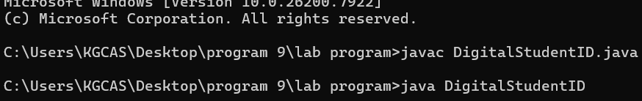

6.2 Login ScreenBefore accessing the system, the admin must log in.
Sample Login Screen:----------------------------------------- LOGIN PAGE-----------------------------------------Username : ____________Password : ____________ [ LOGIN ] [ RESET ]-----------------------------------------
Explanation:
User enters username and password
If correct → system opens main menu
If wrong → error message is shown
This ensures security and restricted access.
6.3 Menu ScreenAfter login, the system displays options.----------------------------------------- MAIN MENU-----------------------------------------1. Add Student2. View Students
3. Search Student4. Update Student5. Delete Student6. ExitEnter your choice: ___----------------------------------------
Explanation:
User selects operation
System performs selected function

6.4 Output Screens
The Output Screen displays the result after processing input

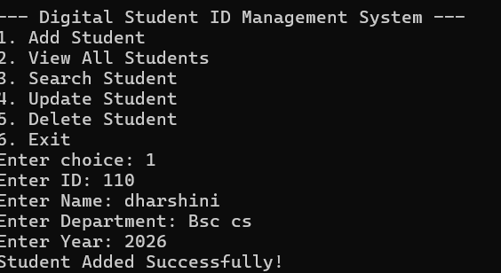

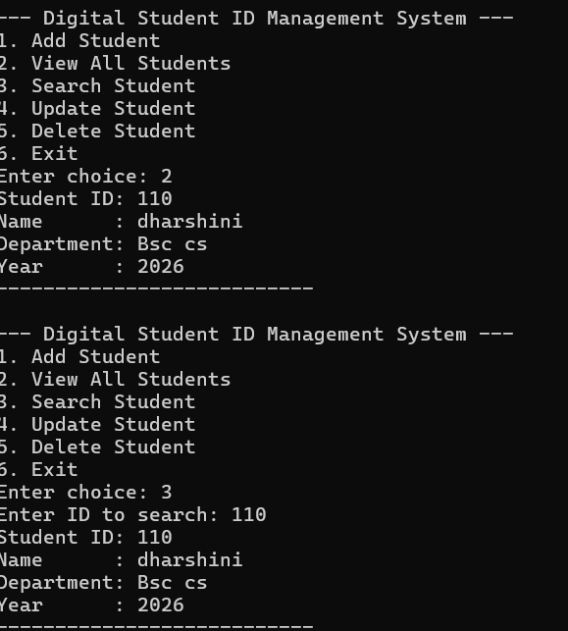

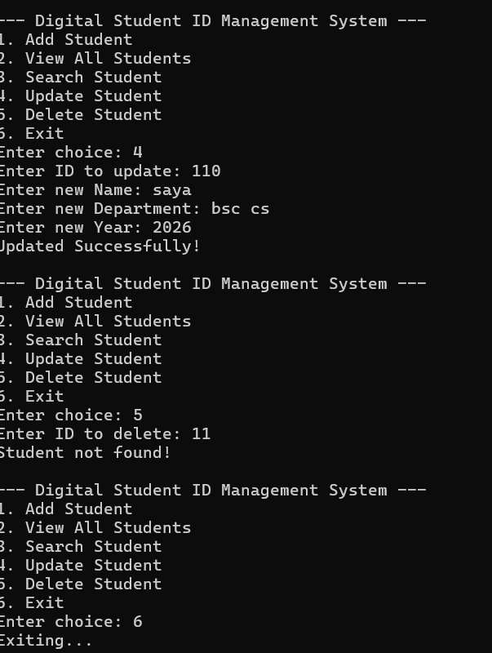

DISCUSSION & CONCLUSION

7.1 Discussion

The Digital Student ID Management System was developed to address the limitations of traditional manual systems used in educational institutions. During the development and implementation of this project, several important aspects were analyzed, tested, and evaluated to ensure the effectiveness of the system.One of the key observations from this project is that digital systems significantly improve the efficiency of managing student records. In the manual system, maintaining student details requires a lot of paperwork, which is time-consuming and prone to errors. By implementing this system, all student data is stored in a structured and organized manner, making it easy to access and manage.The use of Java programming language played a crucial role in the development of this system. Java provides platform independence, which means the application can run on different systems without modification. It also supports object-oriented programming, which helps in organizing the code into reusable modules such as student registration, ID generation, and data management. This made the system more flexible and easier to maintain.Another important aspect discussed during the project is data security. In the manual system, there is a high risk of data loss, unauthorized access, and duplication. The digital system overcomes these issues by implementing login authentication and controlled access. Only authorized users can perform operations such as adding, updating, or deleting student records. This ensures that the data remains safe and reliable.The system also improves speed and accuracy. Searching for a student record in a manual system may take several minutes, whereas in the digital system, it can be done instantly using the search feature. This saves time and increases productivity. Additionally, the chances of human errors are greatly reduced, as the system performs automatic validation and processing.During testing, it was observed that the system performs well under normal conditions and can handle multiple records efficiently. However, certain limitations were also identified. For example, the current version of the system is basic and does not include advanced features such as biometric authentication or cloud storage. It also depends on the availability of a computer system, and users need basic technical knowledge to operate it.Another point of discussion is user experience. The system is designed with a simple and user-friendly interface, which makes it easy for administrators to use. However, further improvements can be made by enhancing the graphical interface using advanced technologies like JavaFX.The project also highlights the importance of modular design. Each function of the system is divided into separate modules, which makes development, testing, and maintenance easier. If any changes are required in the future, they can be made without affecting the entire system.In conclusion, the discussion of this project shows that the Digital Student ID Management System is an effective solution for modern educational institutions. It not only improves efficiency and accuracy but also ensures better data management and security. With further enhancements, the system can be expanded into a more advanced and comprehensive solution.
7.2 Conclusion

The Digital Student ID Management System is a simple yet effective solution developed using Java to manage student identity information in a digital format. This system successfully replaces the traditional manual method of handling student records and ID cards with a more efficient, accurate, and secure computerized approach.
Through this project, we have implemented various functionalities such as student registration, data storage, search, update, deletion, and digital ID generation. These features
help in maintaining a centralized database of student information, which can be accessed quickly and easily by authorized users.One of the major achievements of this system is the reduction of manual work. It minimizes paperwork and reduces the chances of human errors. The system also improves the speed of operations, allowing administrators to handle large volumes of student data without difficulty.The use of Java programming language makes the system platform-independent, reliable, and scalable. The modular design of the system ensures easy maintenance and future enhancements. Additionally, the system provides better data security through login authentication and controlled access.Overall, the project demonstrates how digital solutions can improve the efficiency of educational institutions. It provides a strong foundation for developing more advanced systems in the future.

1. REFERENCES

The following resources were used during the development of this project:
Books
Books
1. Herbert Schildt, Java: The Complete Reference, McGraw-Hill Education.
2. Kathy Sierra & Bert Bates, Head First Java, O’Reilly Media.
3. Roger S. Pressman, Software Engineering: A Practitioner’s Approach, McGraw-Hill.
4. Abraham Silberschatz, Henry F. Korth, S. Sudarshan, Database System Concepts, McGraw-Hill.
5. E. Balagurusamy, Programming with Java, McGraw-Hill Education.
6. Ian Sommerville, Software

WebsitesGeeksforGeeks – https://www.geeksforgeeks.org
Used for understanding student management system logic and programs
Java Guides – https://www.javaguides.net
Used for Java project structure and CRUD operations
TechVidvan – https://techvidvan.com
Used for Java Swing and database integration concepts
MyProjectIdeas – https://myprojectideas.com
Used for understanding student management system working
IJERT – https://www.ijert.org
Used for reference on system design and project documentation

